**THEORY:**

A database is an organized collection of data, generally stored and accessed electronically from a computer system. Where databases are more complex they are often developed using formal design and modeling techniques.

The database management system (DBMS) is the software that interacts with end users, applications, and the database itself to capture and analyze the data. The DBMS software additionally encompasses the core facilities provided to administer the database. The sum total of the database, the DBMS and the associated applications can be referred to as a "database system". Often the term "database" is also used to loosely refer to any of the DBMS, the database system or an application associated with the database.

STEP 1:

Selecting the document to be mail merged.

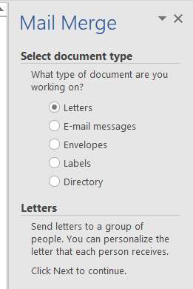

STEP 2:

Selecting the document for mail merge.

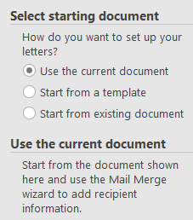

STEP 3:

Selecting the database of contacts for referencing.

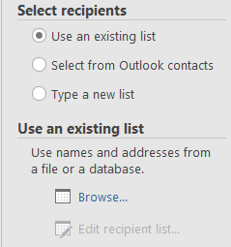

STEP 4:

Selecting the required recipient among the list.

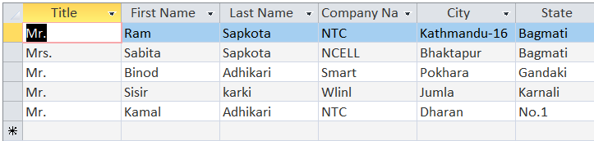

STEP 5:

Selecting the address and greeting line.

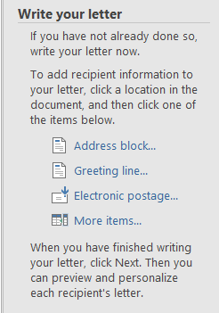

STEP 6:

Inserting the greeting line.

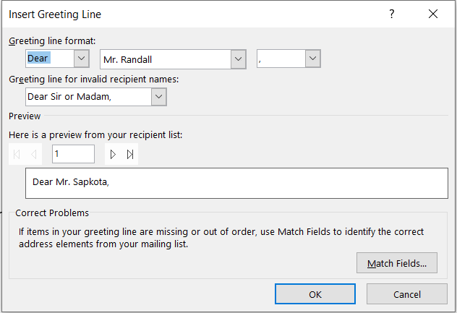

STEP 7:

Previewing the output.

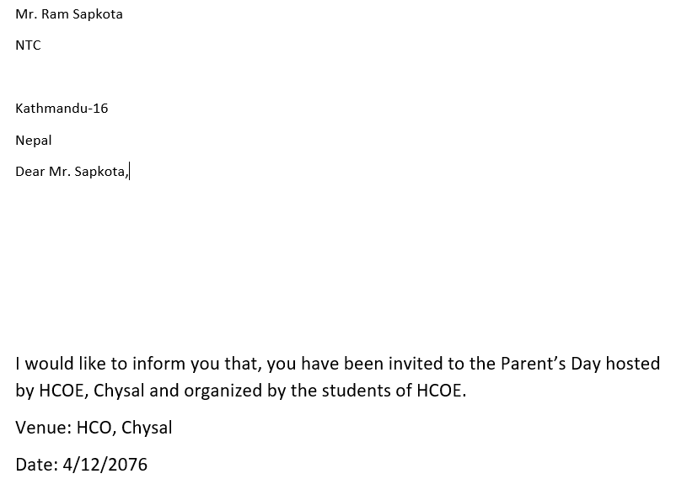

STEP 8:

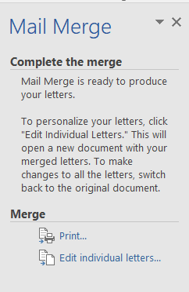 Printing the pamphlet as per requirement.

**CONCLUSION:**

By following these steps we have connected our database and word file and by accessing it we have made the output for each person.